*DBMS Project*

***Submitted by***

*Jatin 102003510*

*Sahil 102183056*

*Himank Tuteja 102183015*

*Tushar Piyush 102003513*

***OTT MANAGEMENT SYSTEM***



Overview

OTT platforms started in India with BigFlix. Launched by Reliance Entertainment in 2008, BigFlix became India's first OTT platform. Eventually, OTT started thriving in India in 2013 after the launch of Zee TV and Sony Liv. Disney Hotstar came into the OTT world in 2015. Viewers of Disney Hotstar are increasing since its launch. Today, it has become one of the most-watched **OTT** platforms.

Later, Netflix began providing its service in India from the beginning of 2016 and competing with the platforms like Amazon-Prime Video and Disney+Hotstar.

In the beginning, [Netflix](https://interestingengineering.com/netflix-stirs-controversy-by-calling-out-53-users-whove-watched-a-film-repeatedly) was purely a movie rental service. Users ordered movies on the Netflix website, and received DVDs in the post. When they were finished with them, they would simply post them back to [Netflix](https://interestingengineering.com/netflix-miniseries-the-mind-explained-explores-the-fascinating-science-of-the-brain) in the envelopes provided.

Today, Netflix streams movies and has more than **208 million** paid subscribers in over **190 countries** around the world. It offers a wide range of TV series, documentaries, and feature films across a wide variety of genres and languages, including original productions.

In this Project, we are going to develop a database from scratch. That means, we would be taking the “**NETFLIX**” as our “**OTT PLATFORM**” and creating an entire schema explaining the connections of different entities, modules in the backend of OTT PLATFORM webpage, and how they interact with each other.

User Requirements

A person decides to watch the show on OTT Platform, for which he needs to buy a subscription, which would be a transaction between CUSTOMER and OTT Platform.

This is where we start noting down the user requirements and build a database which captures transactional and analytical data. Such databases have a smaller number of inserts and updates, as the end goal is to analyze the data as fast as possible.

After discussing, and having good brainstorming sessions with the team, we came up with the following Business Rules for our Database.

* We can classify content into Movies & TV Shows.
* We have different Admins which can log in to platform and can upload the content and they have access to

their customers only.

* Content can be either Movies or TV shows but not both.
* Every content has ContentID which uniquely identifies the content, content title, Release date, ratings. TV Shows have the attribute number of seasons and movies have attribute duration.
* To view the content, a customer must buy a subscription by making a payment. Customers can be identified by a unique identifier CustomerID.
* Other attributes include Name, which is a combination of first and last name, Address, Email, Phone Number.
* Subscription has a unique identifier SubscriptionID. Other attributes are Subscription type, Price.
* Payment is made by the customer to buy a subscription.
* It is uniquely identified by PaymentID, and other attributes are Payment Method, Billing Date and Amount Paid.
* A Customer must make at least one payment and a payment must have one and only one customer.
* A subscription can have many customers and a customer should have at least one subscription.
* A content must have at least one or many genres, and a genre should belong to one or many contents.
* A subscription may have at least one or many contents and a content must be part of at least one subscription.

Module Description

MODULEWISE DESCRIPTION

This project divided into four modules. As stated earlier, the database maintains information about the customers making a transaction with OTT Platform, transaction made for a subscription type and there are different contents available in subscription type.

MODULE-1:

Module-1 deals with the Customer information. A customer has to enter his basic information to buy a subscription. This information entered is stored in the customer table.

MODULE-2:

Module-2 deals with payments made by the customer to buy a subscription.

MODULE-3:

Module-3 deals with the type of subscription that OTT Platform is offering for a particular cost. Each subscription has different content ids, screen resolution and number of users.

MODULE-4:

Module 4 deals content. Content is divided into TV shows; Movies and these TV shows and movies are further classified into different genres.

Conceptual and Logical Database Designing

E-R Model:

This is the Entity-Relationship Model.

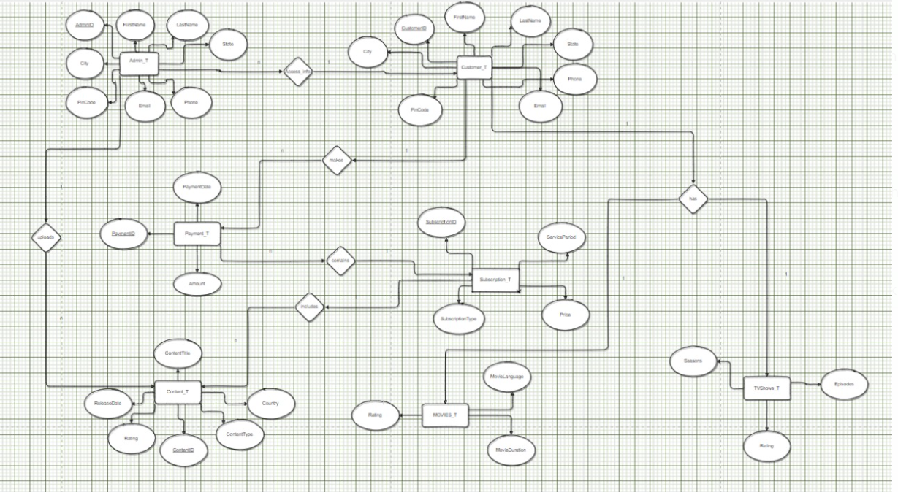

Implementation:

The ER model is normalized to its 3rd Normal Form and thus the Relational Model is created. This form helps in database table creation.

1. ADMIN_T

CREATE TABLE ADMIN_T(

AdminID int PRIMARY KEY,

FirstName varchar(25),

LastName varchar(25),

City varchar(20),

State varchar(20),

PinCode int,

Email varchar(30) UNIQUE,

Phone varchar(10) NOT NULL UNIQUE);

INSERT INTO ADMIN_T

VALUES('1001','Tushar','Piyush','Siwan','Bihar','841234','yysiipqouiouw@gmail.com','2893787987');

INSERT INTO ADMIN_T

VALUES('1002','Himank','Tuteja','Patiala','Punjab','715273','yysiwggpqouiouw@gmail.com','282378 7987');

INSERT INTO ADMIN_T

VALUES('1003','Sahil','Rohilla','Rohtak','Haryana','812634','sahilsiipqouiouw@gmail.com','2834587987');

INSERT INTO ADMIN_T

VALUES('1004','Jatin','Bumrah','Gurdaspur','Punjab','876123','jatinsiwd23@gmail.com','9993787987'

);

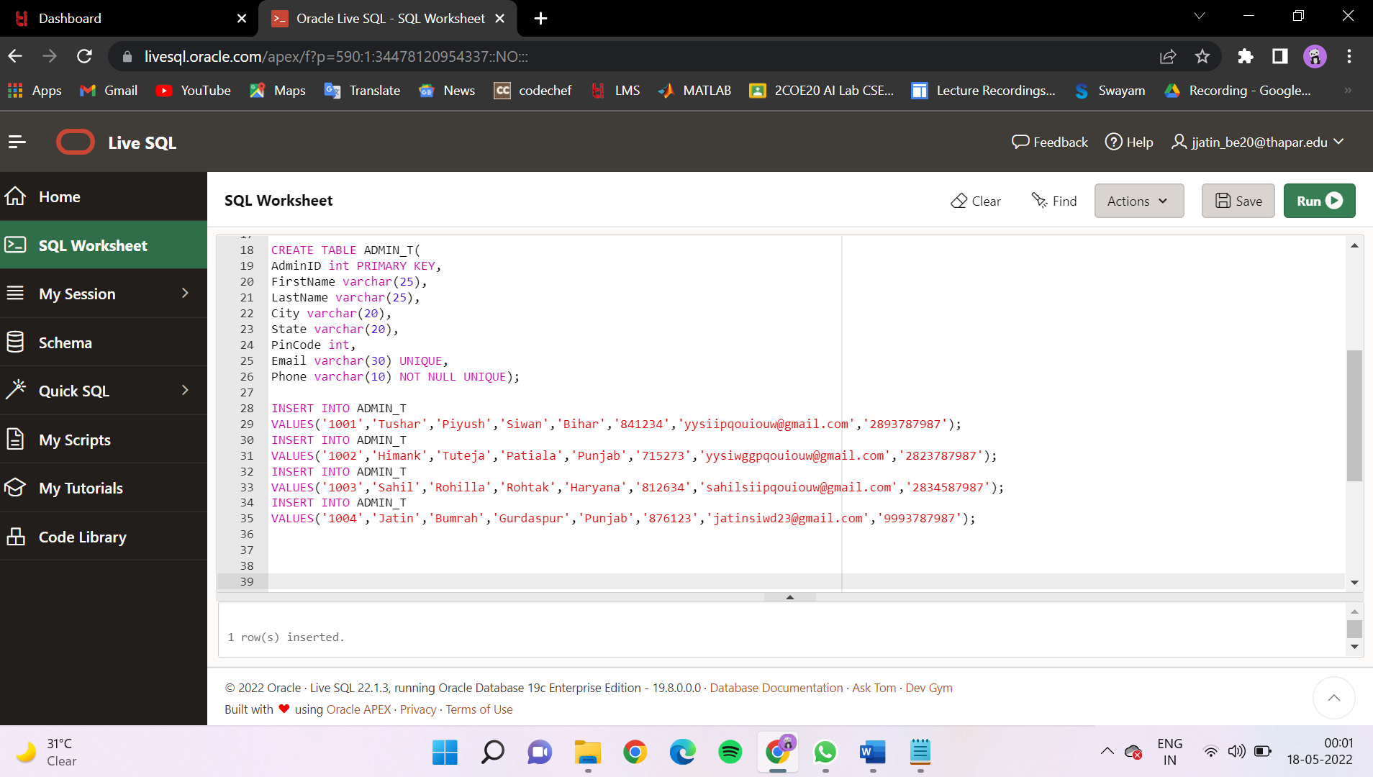

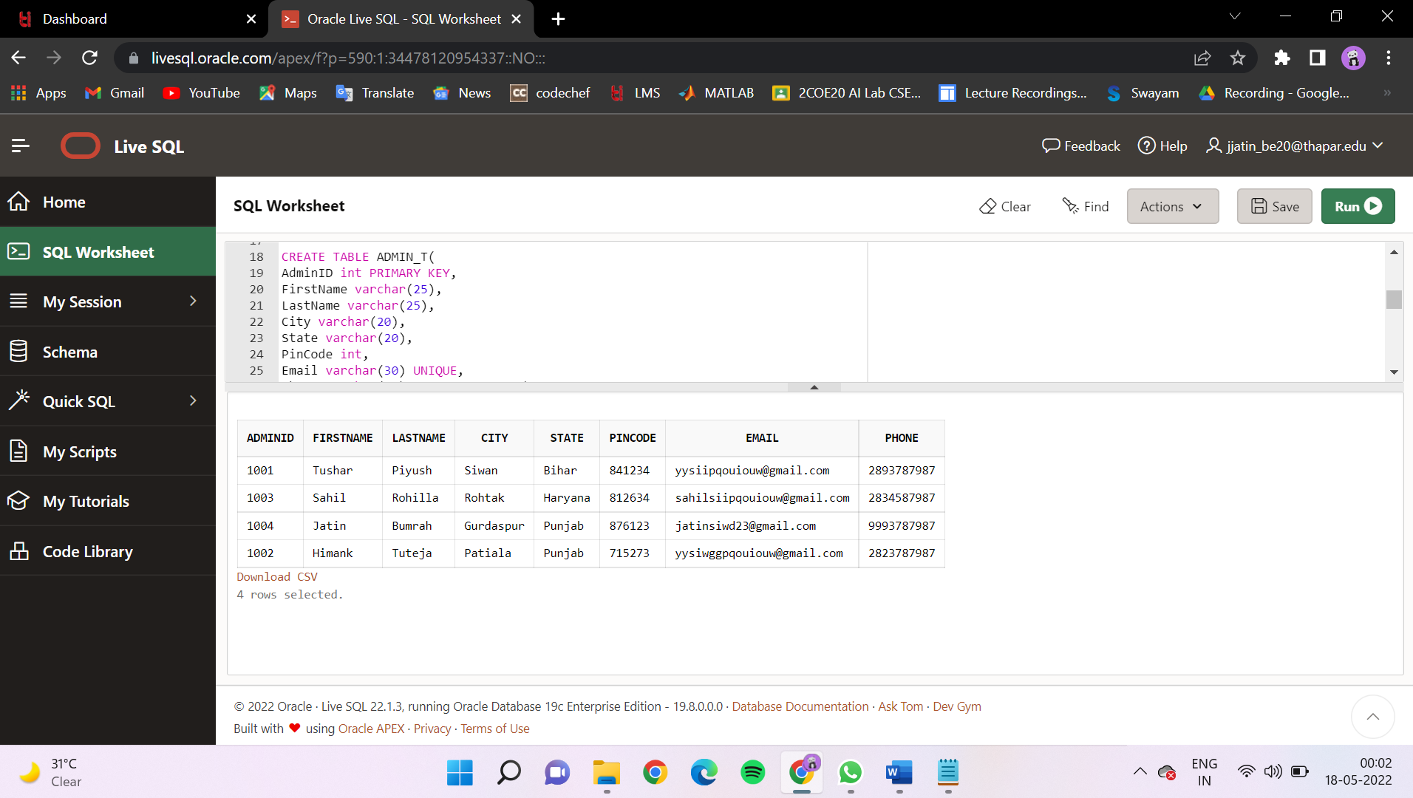

2. Customer_T

CREATE TABLE Customer_T(

CustomerID int PRIMARY KEY,

FirstName varchar(20),

LastName varchar(20),

City varchar(20),

State varchar(20),

PinCode int,

Email varchar(30) UNIQUE,

Phone varchar(10) NOT NULL UNIQUE,

AdminID int REFERENCES ADMIN_T(AdminID),

DOB date);

INSERT INTO Customer_T VALUES('10200351','Tushar','Piyush','Siwan','Bihar','841234','tupiyush_be20@thapar.edu','7002116945','1004','25-oct-1980');

INSERT INTO Customer_T VALUES('10200352','Rohit','Sharma','Mumbai','Maharastra','841235','rsharma5151@gmail.com','7002139945','1002','12-jan-1981');

INSERT INTO Customer_T VALUES('10200353','Rohit','Singh','Mumbai','Maharastra','841235','rsingh5151@gmail.com','7122139945','1003','11-jan-1982');

INSERT INTO Customer_T VALUES('10200354','Rakesh','Singh','Patiala','Punjab','147004','rakeshsingh6151@gmail.com','7122139955','1001','10-aug-1983');

INSERT INTO Customer_T VALUES('10200355','Jatin','Bumrah','Patiala','Punjab','147004','jatinghsyt7625@gmail.com','6122139945','1004','05-dec-1979');

INSERT INTO Customer_T VALUES('10200356','Himank','Tuteja','Rohtak','Haryana','124001','huimankhsdf@gmail.com','7122138945','1003','03-jan-1977');

INSERT INTO Customer_T VALUES('10200357','Sahil','Rohilla','Rohtak','Haryana','124001','sahilrohilla2885@gmail.com','711213945','1002','21-oct-1984');

INSERT INTO Customer_T VALUES('10200358','Zeeshan','Khan','Banaras','UttarPradesh','263897','udghshjgh@gmail.com','2654317890','1001','18-oct-1969');

INSERT INTO Customer_T VALUES('10200359','Ojas','Soni','Hoshiarpur','Punjab','563897','gghsdvsa75249j@gmail.com','9999543267','1004','10-jan-1984');

INSERT INTO Customer_T VALUES('10200360','Sopan','Gangrade','Indore','MadhyaPradesh','963897','ushghdchshjgh@gmail.com','2654325890','1001','12-aug-1964');

INSERT INTO Customer_T VALUES('10200361','Aditya','Gupta','Hoshiarpur','Punjab','563897','adityagupta@gmail.com','7165244687','1001','10-jan-1981');

INSERT INTO Customer_T VALUES('10200362','Shiv','Chauhan','Chapra','Bihar','841236','shivhshjgh@gmail.com','9876317890','1004','17-jan-1980');

INSERT INTO Customer_T VALUES('10200363','Manendar','Singh','Patiala','Punjab','641897','manendarjgh@gmail.com','9456717890','1004','26-feb-1981');

INSERT INTO Customer_T VALUES('10200364','Sirtaj','Sandhu','Hoshiarpur','Punjab','563897','Sirtajshjgh@gmail.com','9771405890','1001','19-feb-1959');

INSERT INTO Customer_T VALUES('10200365','Vasu','Prabhakar','Hoshiarpur','Punjab','563897','udgvasuh@gmail.com','7005431789','1004','27-oct-1994');

INSERT INTO Customer_T VALUES('10200366',' Tanishq','Anand','Merut','UttarPradesh','673897','anandh@gmail.com','6666667890','1004','21-jan-1992');

select * from Customer_T;

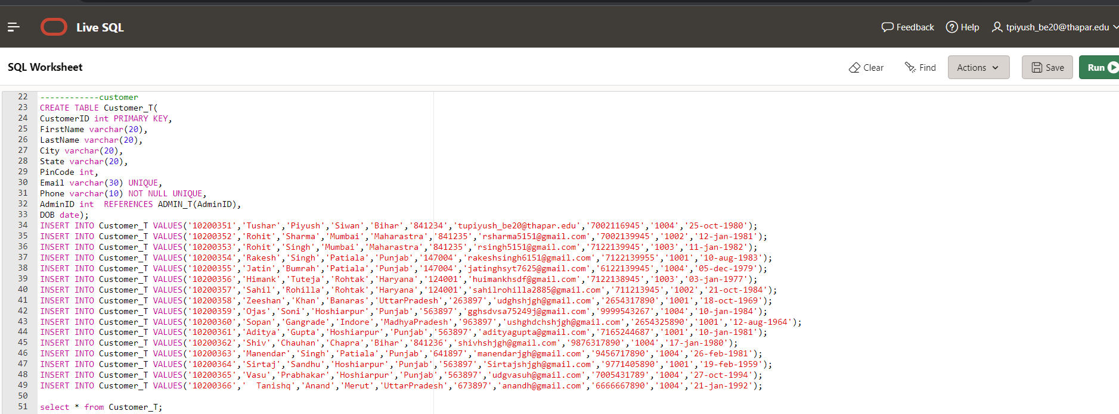

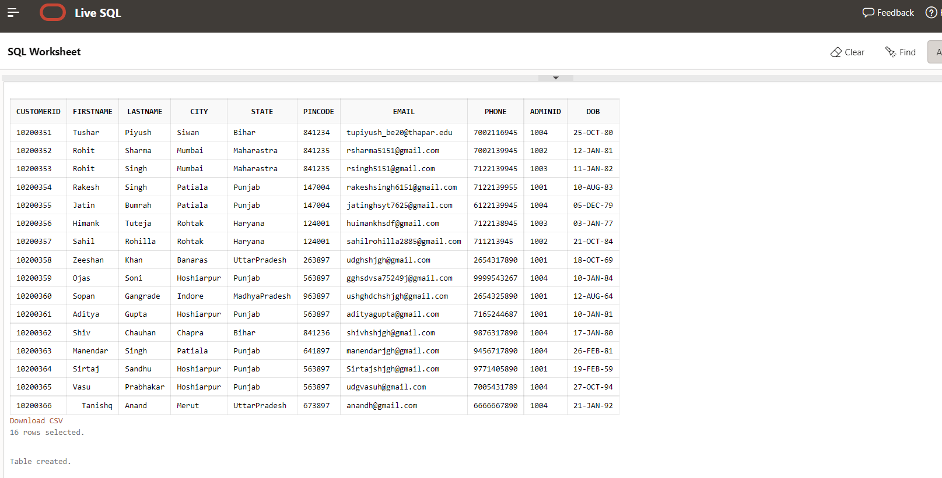

3. Subscription_T

CREATE TABLE Subscription_T (

SubscriptionId number(3),

SubscriptionType VARCHAR(10),

Price number(10,2),

ServicePeriod number(2),

PRIMARY KEY(SubscriptionId)

);

-----service period in months-------

INSERT INTO Subscription_T VALUES (701,'Basic',400,3);

INSERT INTO Subscription_T VALUES (702,'Standard',800,6);

INSERT INTO Subscription_T VALUES (703,'Premium',1200,12);

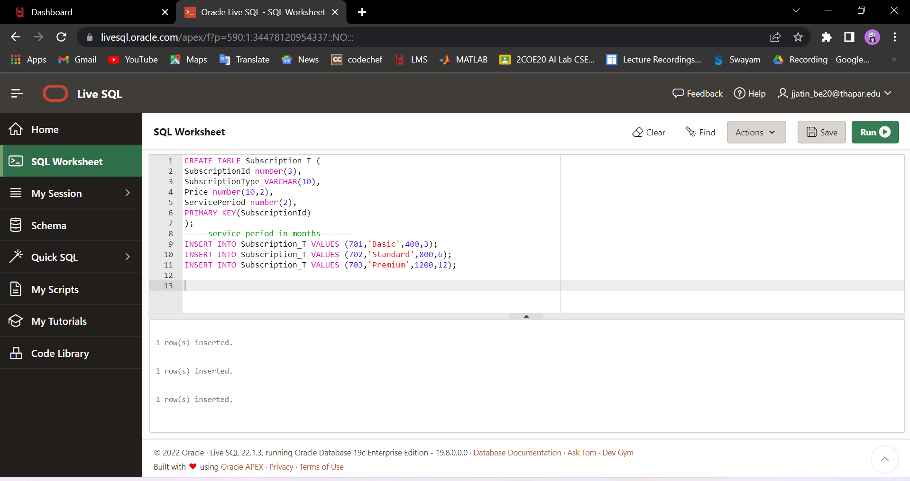

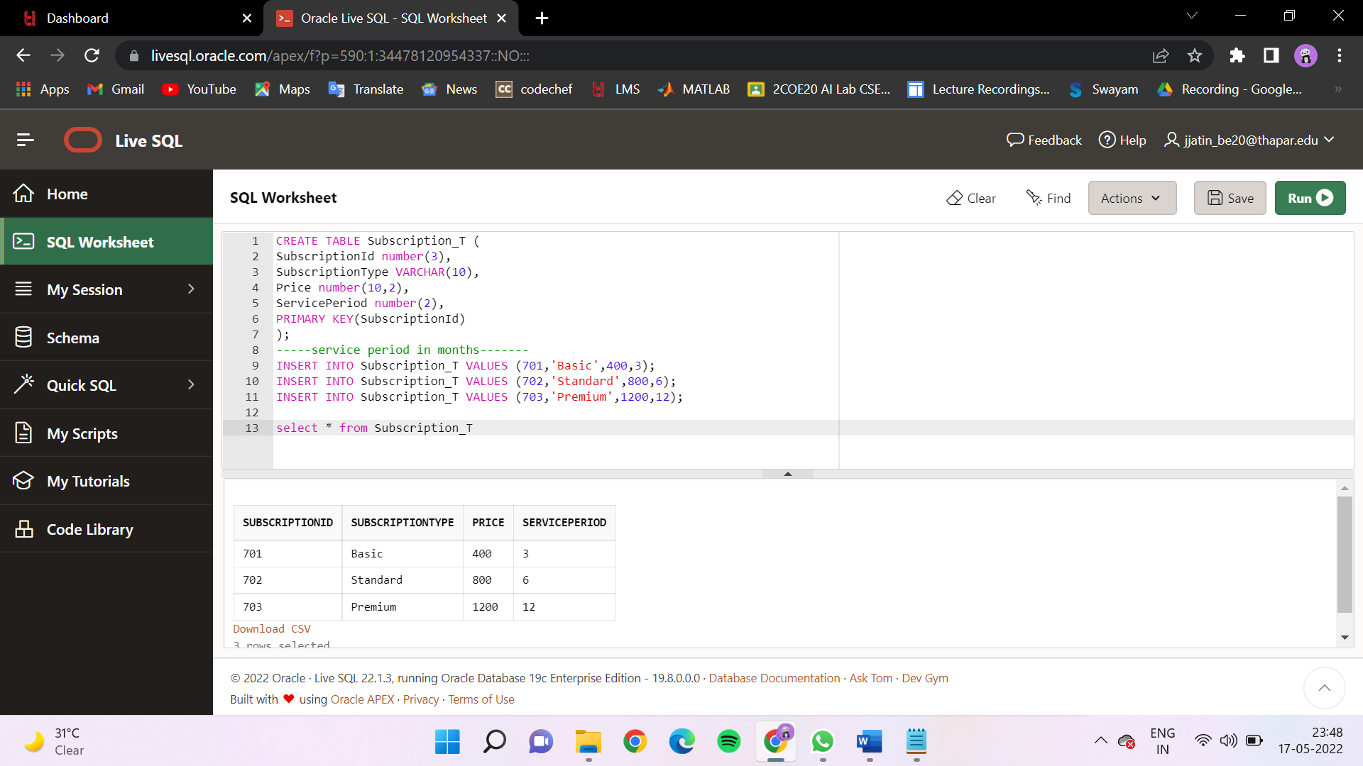

4. PAYMENT_T

CREATE TABLE PAYMENT_T(

PaymentID int PRIMARY KEY,

Amount int,

PaymentDate Date,

CustomerID int REFERENCES Customer_T(CustomerID),

SubscriptionID number(3) REFERENCES Subscription_T(SubscriptionId));

INSERT INTO PAYMENT_T VALUES('1021','400','25-oct-2000','10200351','701');

INSERT INTO PAYMENT_T VALUES('1022','800','25-oct-2002','10200351','702');

INSERT INTO PAYMENT_T VALUES('1023','800','25-aug-2003','10200351','702');

INSERT INTO PAYMENT_T VALUES('1024','1200','25-oct-2000','10200352','703');

INSERT INTO PAYMENT_T VALUES('1025','400','25-jan-2005','10200353','701');

INSERT INTO PAYMENT_T VALUES('1026','800','25-oct-2006','10200353','702');

INSERT INTO PAYMENT_T VALUES('1027','1200','27-feb-2001','10200354','703');

INSERT INTO PAYMENT_T VALUES('1028','400','25-oct-2007','10200355','701');

INSERT INTO PAYMENT_T VALUES('1029','800','20-aug-2000','10200356','702');

INSERT INTO PAYMENT_T VALUES('1030','400','14-jan-2001','10200357','701');

INSERT INTO PAYMENT_T VALUES('1031','1200','15-oct-2003','10200357','703');

INSERT INTO PAYMENT_T VALUES('1032','400','25-oct-2000','10200358','701');

INSERT INTO PAYMENT_T VALUES('1033','800','10-aug-2010','10200359','702');

INSERT INTO PAYMENT_T VALUES('1034','1200','13-jan-2000','10200360','703');

INSERT INTO PAYMENT_T VALUES('1035','400','15-oct-2000','10200361','701');

INSERT INTO PAYMENT_T VALUES('1036','800','09-oct-2000','10200362','702');

INSERT INTO PAYMENT_T VALUES('1037','800','08-aug-2000','10200363','702');

INSERT INTO PAYMENT_T VALUES('1038','1200','01-feb-2000','10200364','703');

INSERT INTO PAYMENT_T VALUES('1039','800','25-oct-2013','10200365','702');

INSERT INTO PAYMENT_T VALUES('1040','800','15-jan-2012','10200366','702');

INSERT INTO PAYMENT_T VALUES('1041','400','26-oct-2011','10200366','701');

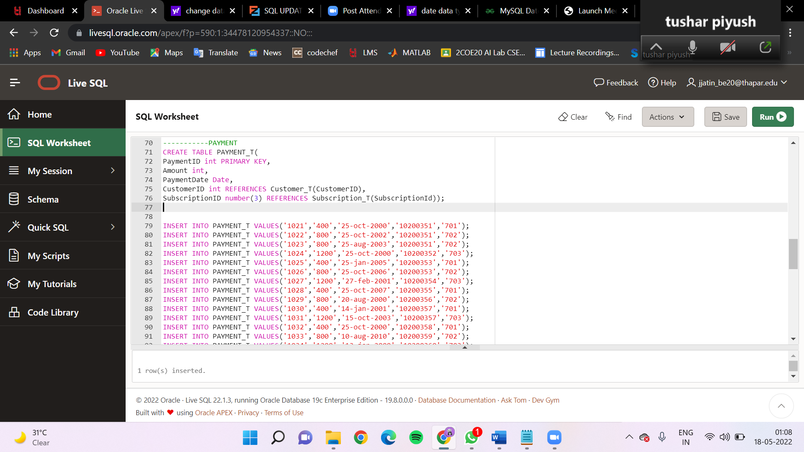

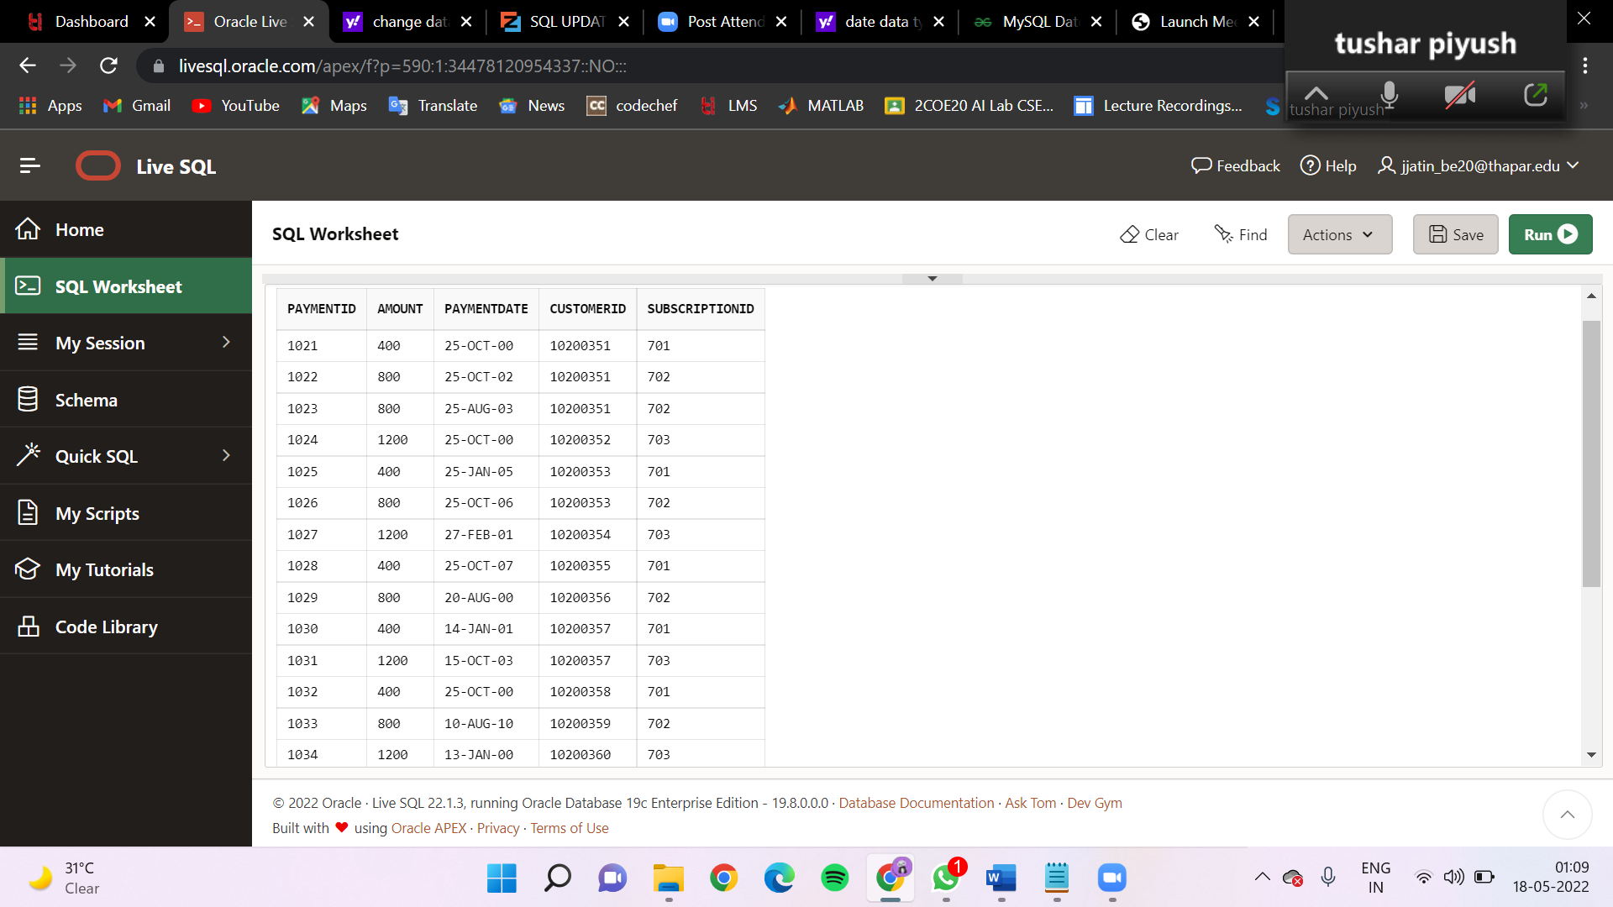

5. Content_T

CREATE TABLE Content_T (

ContentId number(3) primary key,

ContentTitle VARCHAR(50),

ReleaseDate DATE,

Rating number(2),

Country VARCHAR(256),

ContentType VARCHAR(10),

AdminID int REFERENCES ADMIN_T(AdminID),

SubscriptionId number(3) references Subscription_T(SubscriptionId)

);

INSERT INTO Content_T VALUES (501,'Harry Potter','12-Aug-2012',7,'USA','Movie',1001,701);

INSERT INTO Content_T VALUES (502,'Ninja Fight','11-Jan-2008',8,'China','TV SHOW',1002,702);

INSERT INTO Content_T VALUES (503,'RRR','20-Feb-2007',9,'India','Movie',1003,703);

INSERT INTO Content_T VALUES (504,'Kdrama','23-Mar-2010',5,'Korea','Movie',1004,701);

INSERT INTO Content_T VALUES (505,'Fast and Furious','18-Dec-2016',6,'USA','TV SHOW',1001,702);

INSERT INTO Content_T VALUES (506,'Fighters','01-Apr-2011',6,'China','Movie',1002,703);

INSERT INTO Content_T VALUES (507,'Vande Matram','11-Nov-2016',5,'India','Movie',1003,701);

INSERT INTO Content_T VALUES (508,'Love Birds','02-Sep-2013',7,'Korea','TV SHOW',1004,702);

INSERT INTO Content_T VALUES (509,'Attack','18-Oct-2015',7,'USA','Movie',1001,703);

INSERT INTO Content_T VALUES (510,'Kunfu','08-Dec-2016',8,'China','Movie',1002,701);

INSERT INTO Content_T VALUES (511,'Pyaar ki raat','02-Jan-2004',9,'India','TV SHOW',1003,702);

INSERT INTO Content_T VALUES (512,'Romance','22-Feb-2005',9,'Korea','Movie',1004,703);

INSERT INTO Content_T VALUES (513,'Avengers','28-Mar-2006',4,'USA','Movie',1001,701);

INSERT INTO Content_T VALUES (514,'Pyaar tune ye kya kiya','18-Apr-2010',4,'India','TV SHOW',1002,702);

INSERT INTO Content_T VALUES (515,'Kpop','17-May-2019',5,'Korea','TV SHOW',1003,703);

INSERT INTO Content_T VALUES (516,'Singers','07-Jun-2020',8,'USA','TV SHOW',1004,701);

INSERT INTO Content_T VALUES (517,'Batman','27-Feb-2022',9,'USA','Movie',1001,702);

INSERT INTO Content_T VALUES (518,'Shinshan','30-Aug-2021',8,'China','Movie',1002,703);

INSERT INTO Content_T VALUES (519,'Boyz','14-Sep-2021',7,'Korea','Movie',1003,701);

INSERT INTO Content_T VALUES (520,'Family','13-Jan-2022',7,'USA','TV SHOW',1004,702);

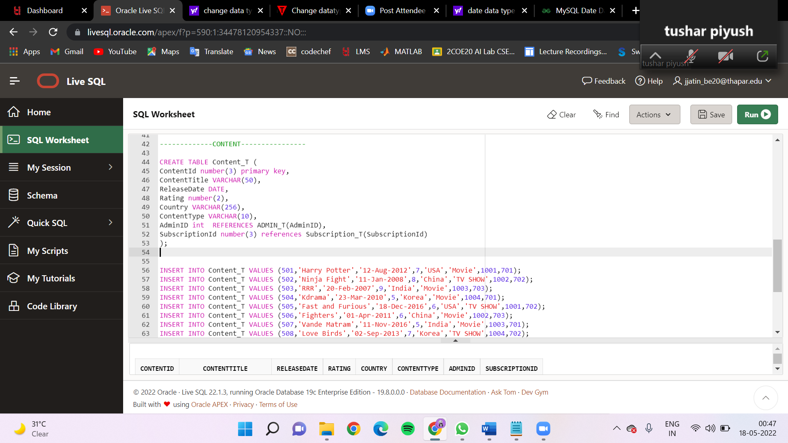

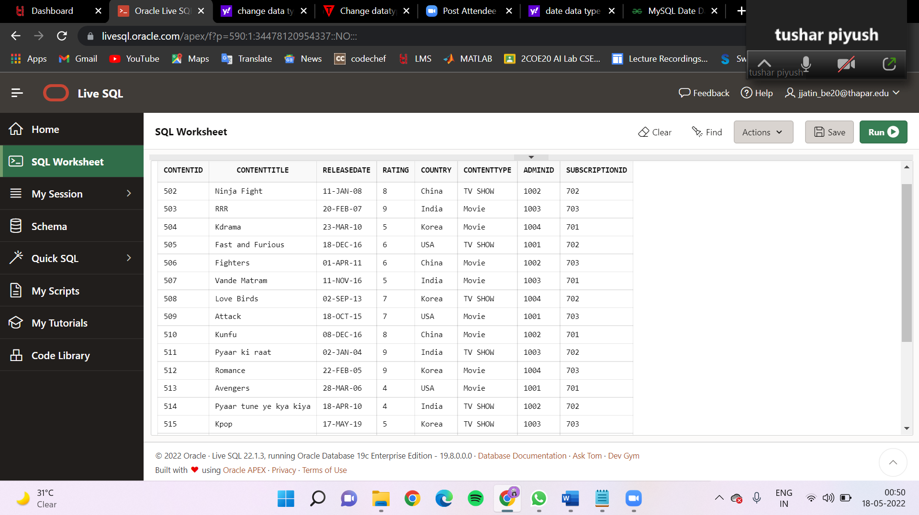

6. TvShows_T

CREATE TABLE TvShows_T (

ContentId number(3) primary key,

Seasons number(2),

Episodes number(2),

FOREIGN KEY (ContentId) REFERENCES Content_T(ContentId)

);

INSERT INTO TvShows_T VALUES (502,3,10);

INSERT INTO TvShows_T VALUES (505,4,22);

INSERT INTO TvShows_T VALUES (508,5,20);

INSERT INTO TvShows_T VALUES (511,1,7);

INSERT INTO TvShows_T VALUES (514,2,8);

INSERT INTO TvShows_T VALUES (515,3,12);

INSERT INTO TvShows_T VALUES (516,4,16);

INSERT INTO TvShows_T VALUES (520,1,9);

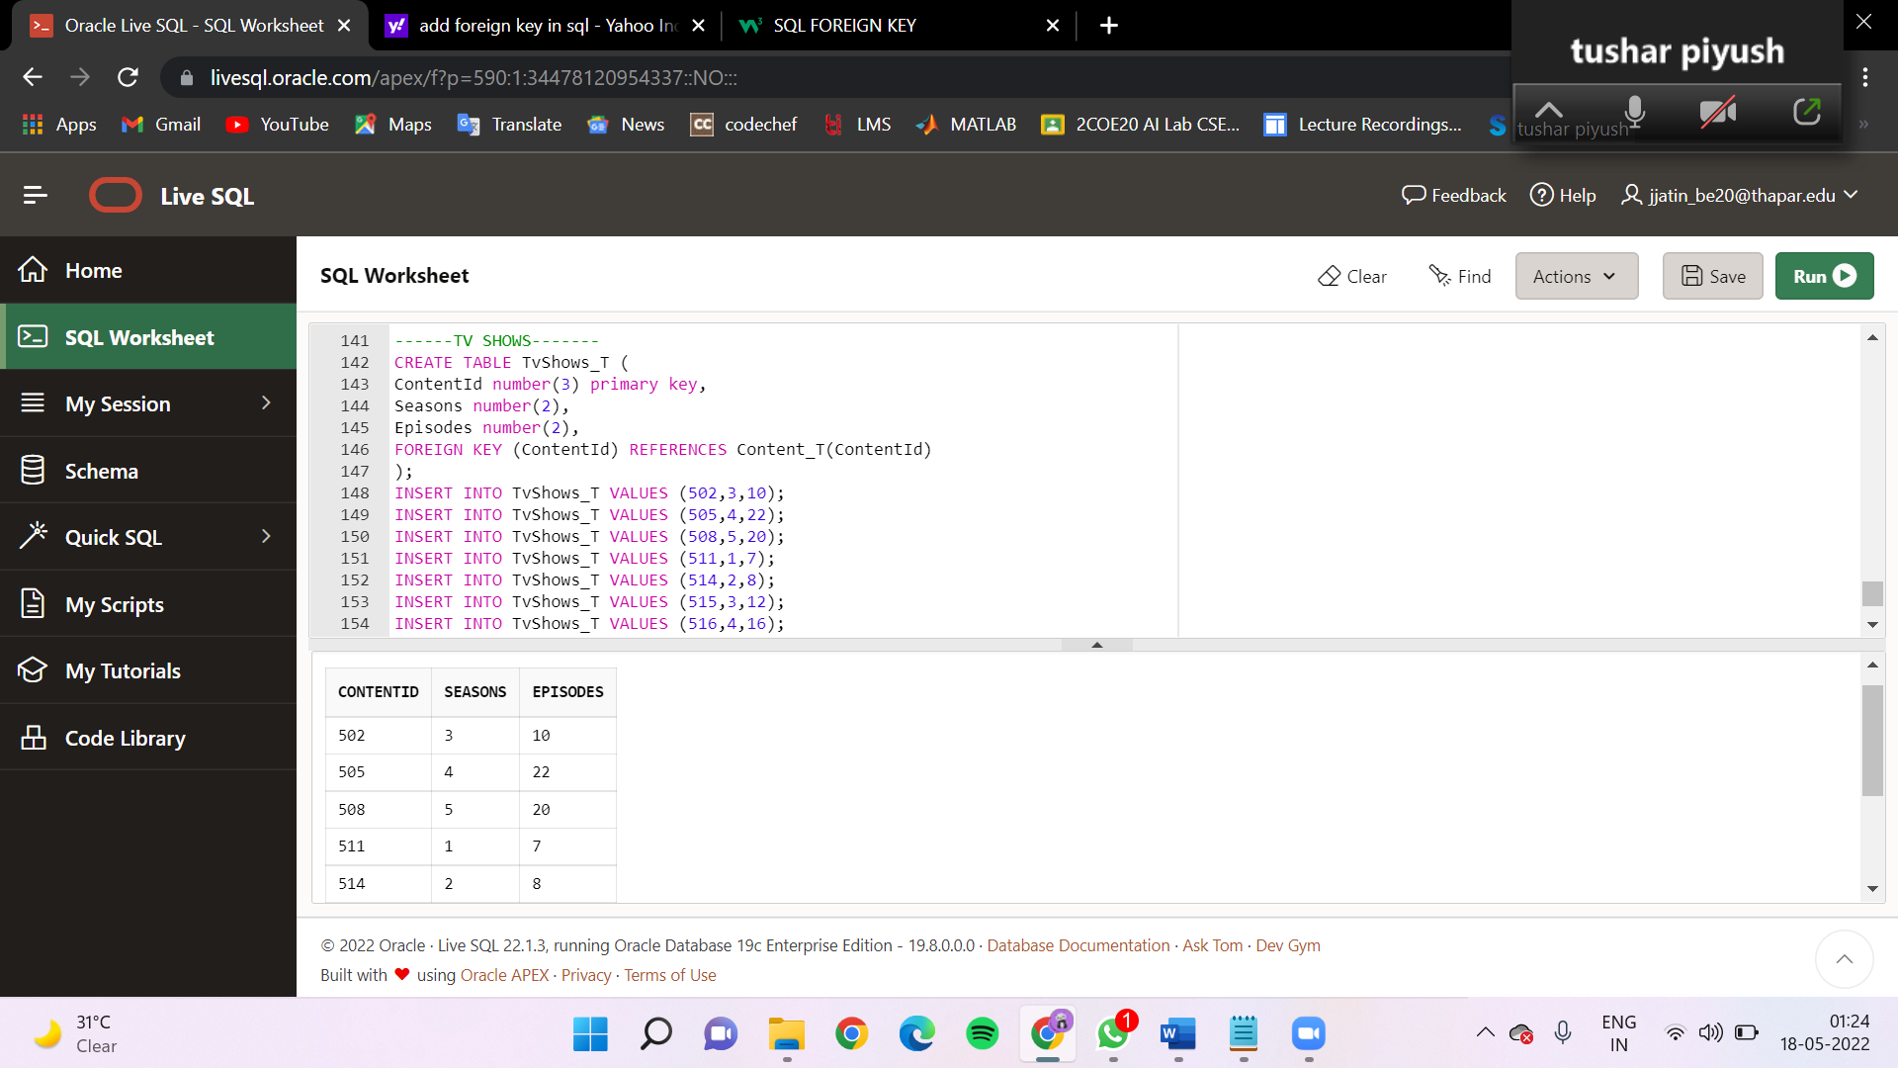

7. Movies_T

CREATE TABLE Movies_T (

ContentId number(3) primary key,

Duration number(3), ------minutes-----

language varchar(10),

FOREIGN KEY (ContentId) REFERENCES Content_T(ContentId)

);

insert into Movies_T values(501,130,'English');

insert into Movies_T values(503,120,'Hindi');

insert into Movies_T values(504,119,'Korean');

insert into Movies_T values(506,140,'Chinese');

insert into Movies_T values(507,120,'Hindi');

insert into Movies_T values(509,109,'English');

insert into Movies_T values(510,145,'Chinese');

insert into Movies_T values(512,135,'Korean');

insert into Movies_T values(513,125,'English');

insert into Movies_T values(517,110,'English');

insert into Movies_T values(518,120,'Chinese');

insert into Movies_T values(519,100,'Korean');

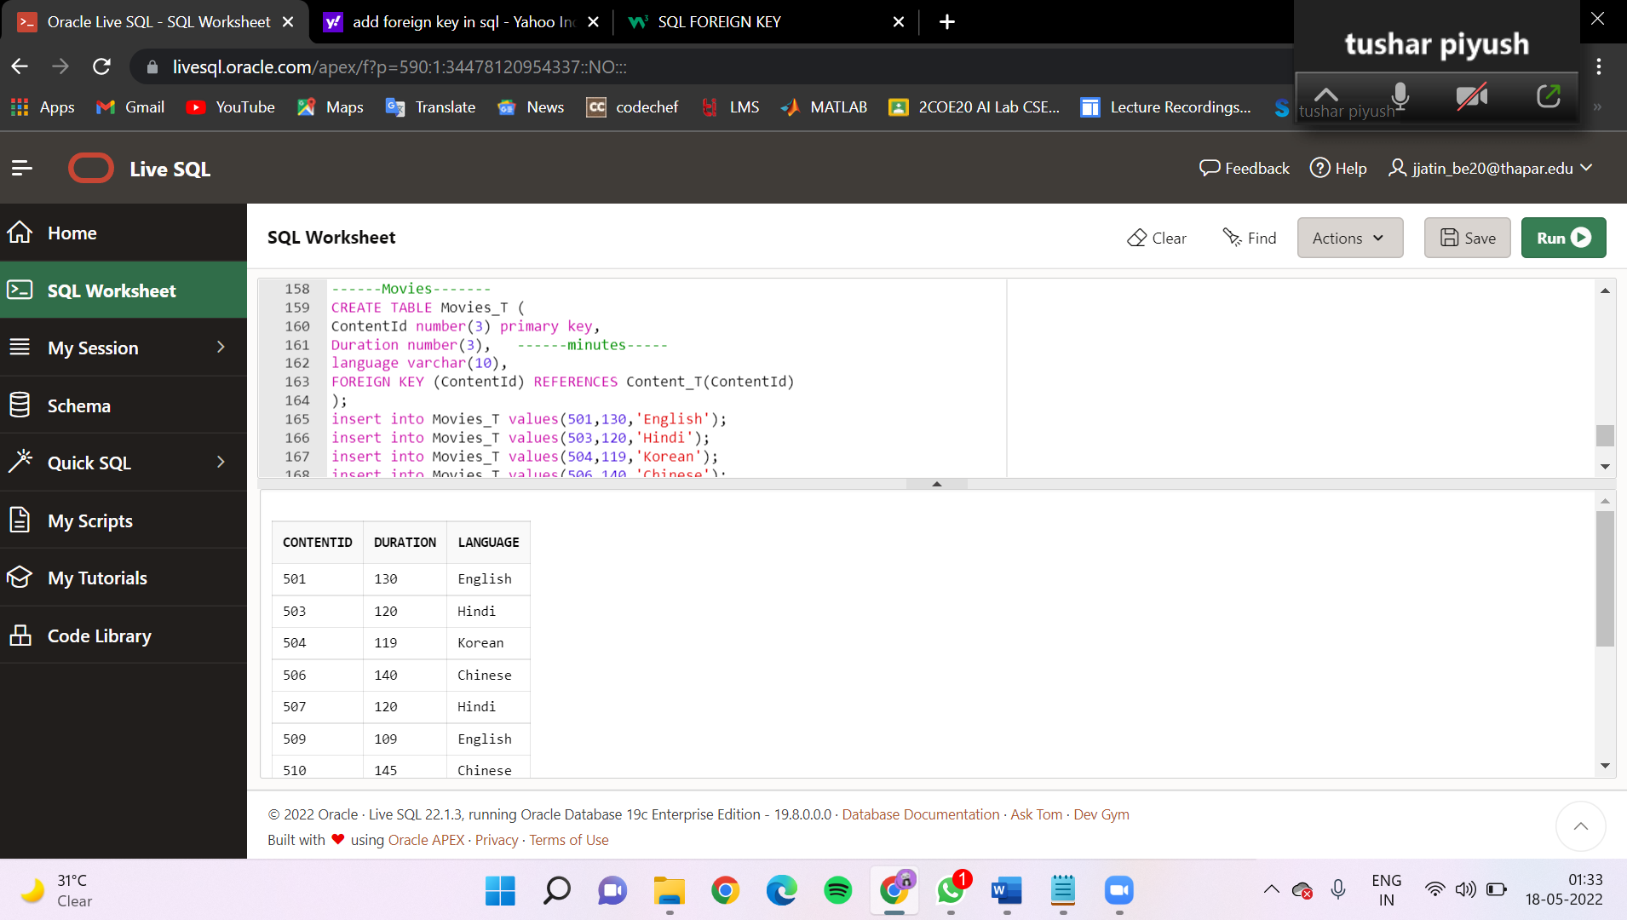

QUERY-1-

This query is a representation of year wise content count. This is achieved by using Group By and Order By.

SELECT ReleaseDate,ContentType,count(distinct ContentId) from Content_T

GROUP BY ReleaseDate,ContentType

ORDER BY ReleaseDate;

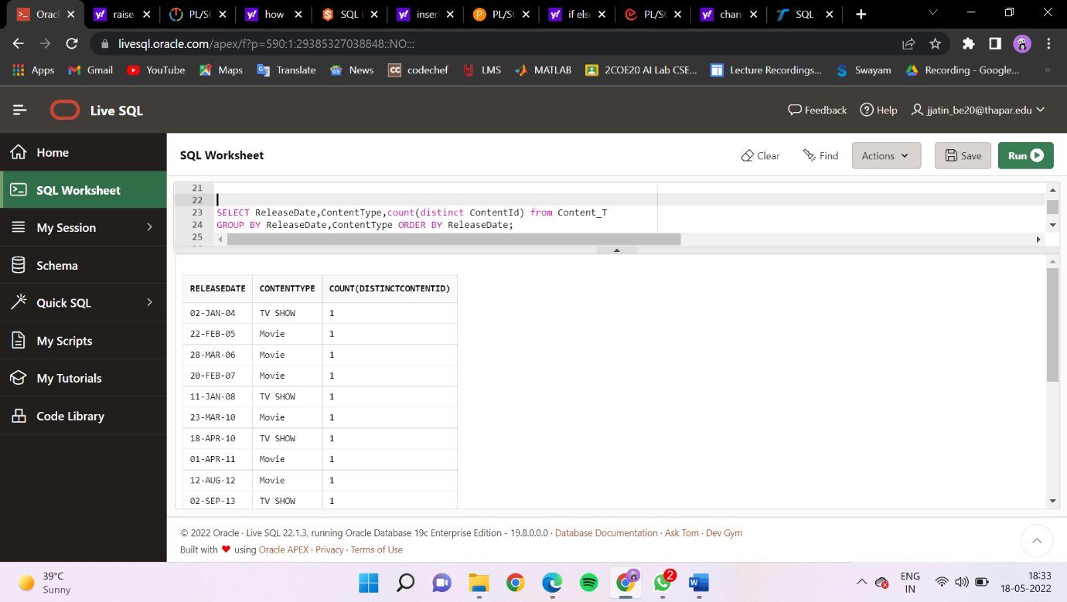

QUERY-2-

This query provides the count of content being produced by different countries. This is achieved by using Group By and Order By.

Select Country,count (ContentId) from Content_T

GROUP BY Country

ORDER BY count (ContentId) DESC;

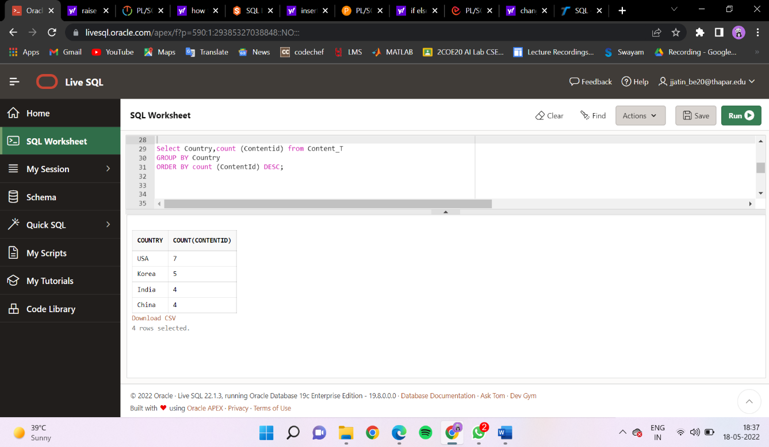

QUERY-3-

Write a query to find the total count of different content types.

SELECT count(ContentId),ContentType FROM Content_T GROUP BY ContentType;

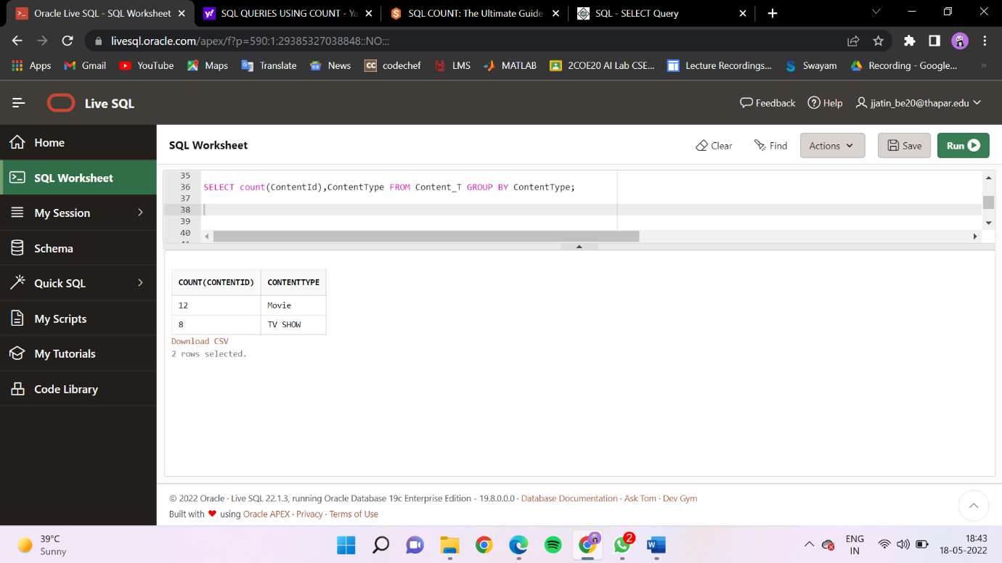

QUERY-4-

Write a query to find the subscription type of the customer

SELECT CustomerID,SubscriptionType FROM Payment_T INNER JOIN Subscription_T ON Payment_T.SubscriptionId=Subscription_T.SubscriptionId;

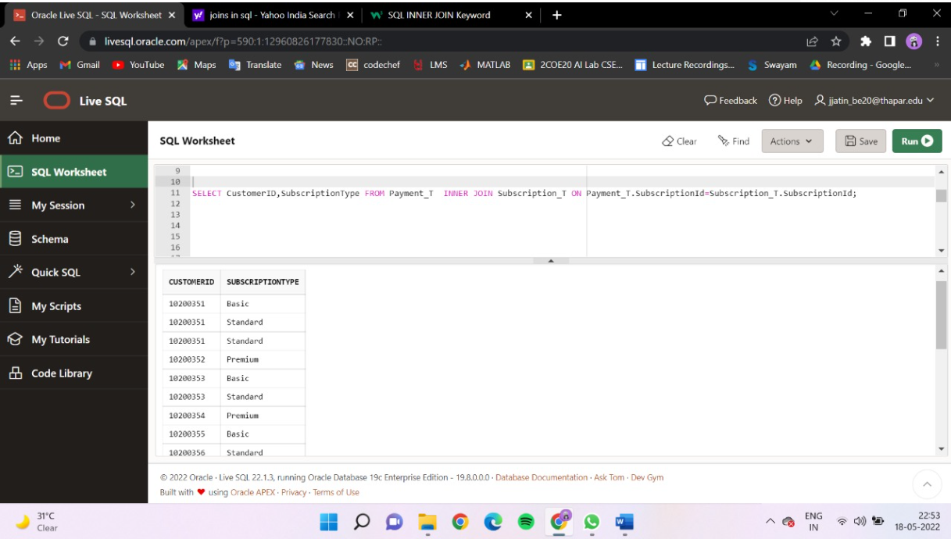

QUERY-5-

Write a query to find when will the scription will end of a customer

SELECT CustomerID,ADD_MONTHS(PaymentDate,ServicePeriod) as expire_date FROM Payment_T INNER JOIN Subscription_T

ON Payment_T.SubscriptionId=Subscription_T.SubscriptionId;

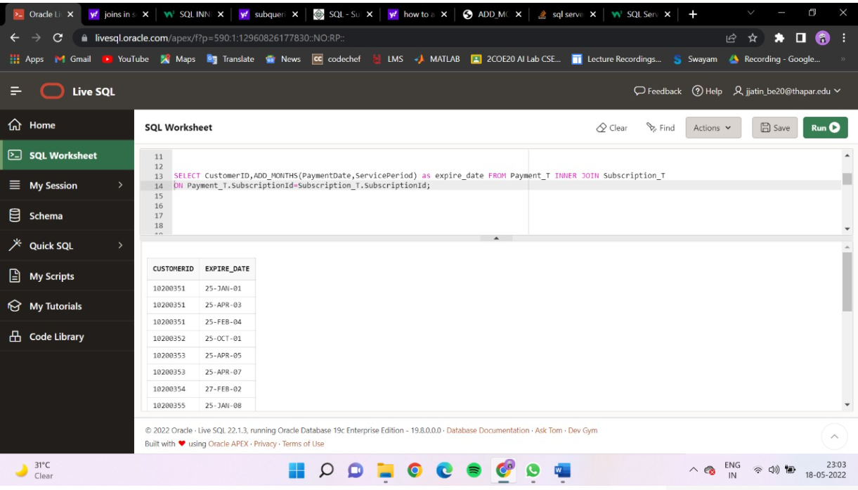

PL/SQL-

Q) Write a PL/SQL code to display the details of customer of

customer id for Customer_T table (using Cursor).

declare

cursor c1 is select FirstName, City,State from Customer_T where CustomerID='10200351';

rec c1%rowtype;

begin

open c1;

loop

fetch c1 into rec;

exit when c1%notfound;

dbms_output.put_line(rec.FirstName||' '|| rec.City||' '|| rec.State);

end loop;

close c1;

end;

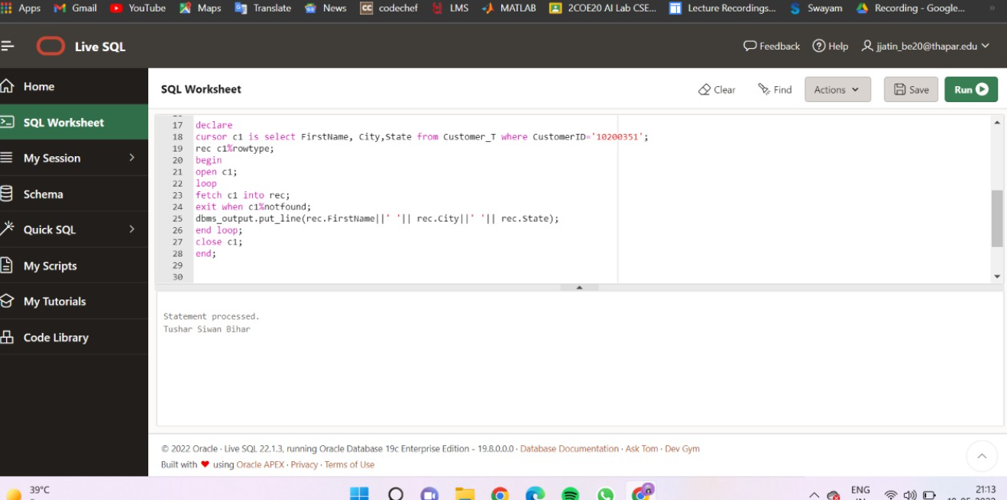

Q) Write a PL/SQL code to display the content detail of top 5

highest rating

content (using Cursor).

declare

cursor c1 is select * from Content_T order by Rating desc;

rec c1%rowtype;

begin

open c1;

loop

fetch c1 into rec;

exit when c1%rowcount>5 or c1%notfound;

dbms_output.put_line(rec.ContentTitle||' '|| rec.ContentId||' '|| rec.Rating);

end loop;

close c1;

end;

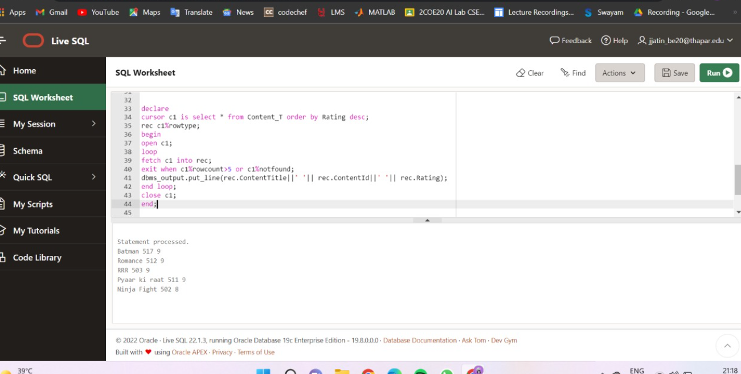

Q) Write a PL/SQL code to display details of admin of id n . The value of n is

passed to cursor as parameter

declare

cursor c1(d int) is

select * from ADMIN_T where AdminID=d;

rec c1%rowtype;

begin

open c1('1001');

loop

fetch c1 into rec;

exit when c1%notfound;

dbms_output.put_line(rec.FirstName||' '|| rec.City||' '|| rec.Email||' '|| rec.Phon

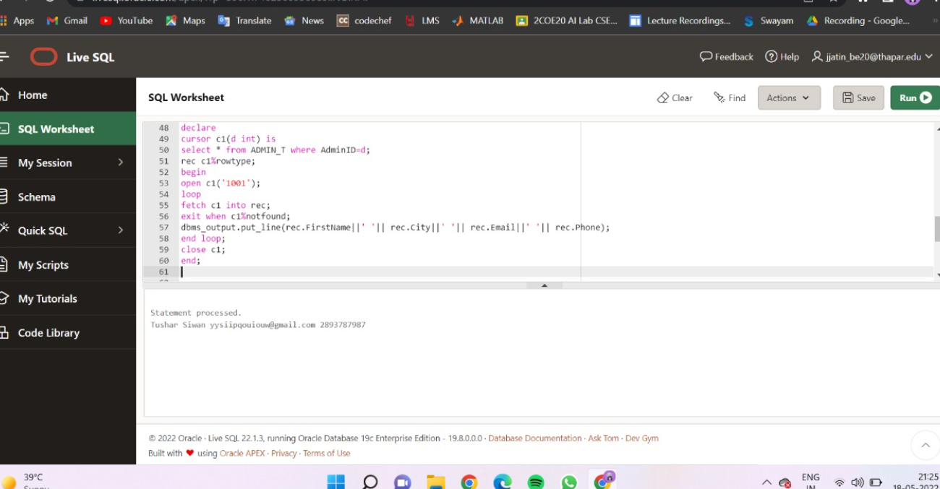end loop;

close c1;

Q)

----Create a trigger to implement the primary key constraint on column Payment_T table.

create or replace trigger p_key

before insert or update on PAYMENT_T

for each row declare en number;

begin

if(:new.PaymentID=NULL) then

raise_application_error(-20002,'primary key cannot be null');

end if;

select PaymentID into en from Payment_T where PaymentID=:new.PaymentID;

raise_application_error(-20003,'primary key cannot have duplicate values'); exception

when no_data_found then

null;

end;

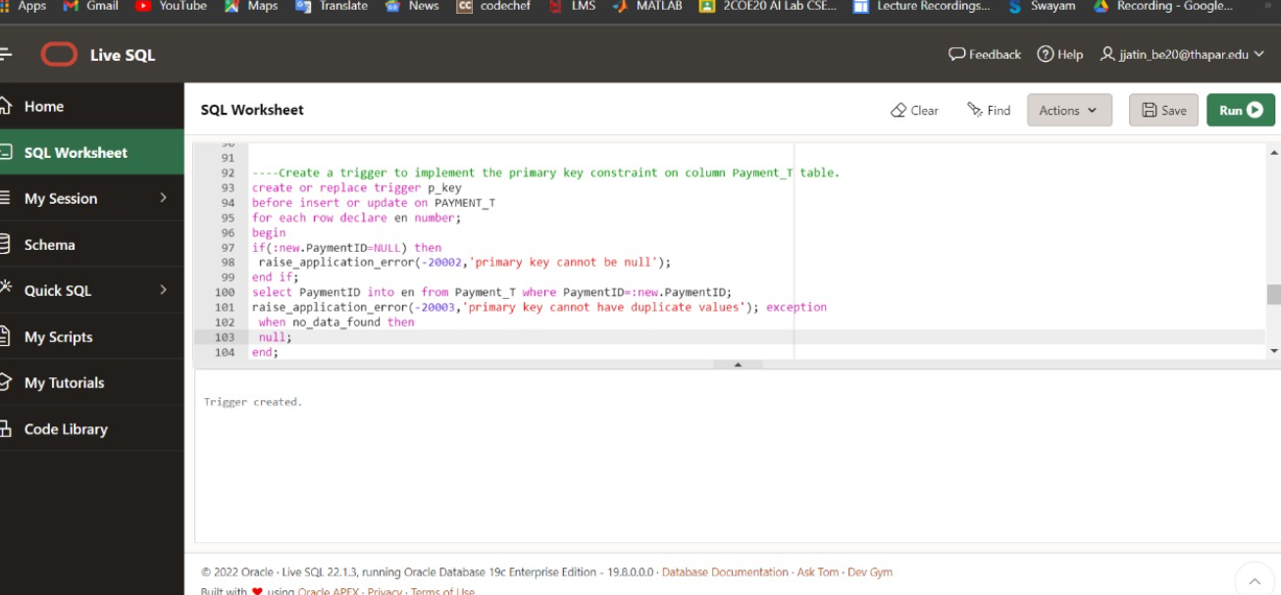

Q) Raise the exception when the customer is trying to access the data which is not available.

declare

a varchar(20);

begin

select ContentTitle into a from Content_T where ContentId=4;

exception

WHEN TOO_MANY_ROWS then

DBMS_OUTPUT.PUT_LINE('TOO MANY ROWS');

WHEN NO_DATA_FOUND then

DBMS_OUTPUT.PUT_LINE('NO DATA FOUND');

END;

